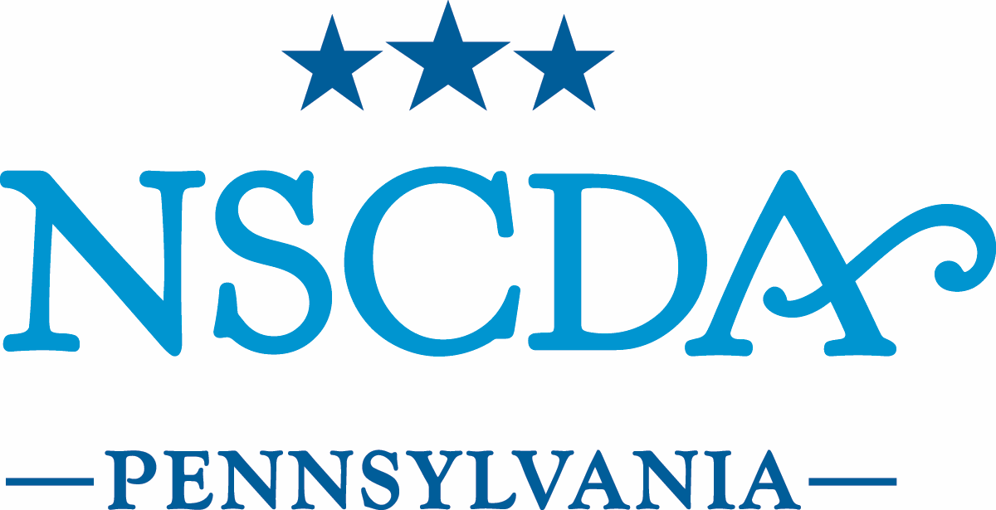

Board of Managers Meeting

MAY 9, 2016

Minutes

- Call to Order: The Board of Managers of The National Society of The Colonial Dames of America in the Commonwealth of Pennsylvania met on May 9, 2016, at Headquarters. Anne Burnett, President, presiding, called the meeting to order at 9:40 am.
Board members: present; excused
Officers
President Anne Burnett
Vice President Barbara Rogers
Governance & Nominating Virginia Whelan
Recording Secretary Catharine Klaus
Treasurer Margaret Conver
Registrar Constance Taylor
Associate States Registrar Sharon Holt
Stenton Chair Carol Rush
Patriotic Service Chair Elizabeth Mills
Historic Activities Chair Katherine Bieniosek

Managers
ACC Committee Chair Genevieve Ebbert
LDY Committee Chair Margaret Broussard
Program Chair DeeDee Heyward
Development Chair Alice Lea Tasman
Headquarters Chair Jane Foster Willson
Membership Chair Rebecca O’Neill
Assistant Treasurer Barbara Wood
Member-at-Large Elizabeth Marshall
Member-at-Large Gayla McCluskey

Honorary Members
Historian Elizabeth Laurent
Lady of Dumbarton Elise Carr
Assoc. Trustee, Friends of Sulgrave Manor Lisa Street
Regent of Gunston Hall Kristin Cahn von Seelen
Stenton Executive Director Dennis Pickeral
Headquarters Executive Assistant Adriana Robinson

NSCDA PA Past Presidents
Susan Armstrong
Barbara Cauffman
Sarah Congdon
Martha Lewis
Nancy Nimick (Honorary NSCDA PA President and Past National President)
Dora Rogers
Margaret Schiffer
Peggy Shaver
Alice Lea Tasman

BOM (to serve out terms)
Lee Manonian 2017
Eleanor Peterson 2017
Julia Ward 2017
Cornelia Schaefer 2018
Wendy Wells-Finn (phone) 2018

II. Minutes
A motion was made by Alice Lea Tasman and seconded by Carol Rush to approve the April 2016 minutes with the following corrections: “Kristin Cahn von Seelen listed as PA Regent of Gunston Hall, not First Regent; also, all honorary member should be included on the minutes cover page. The motion was approved.

III. Brief Updates

A. Development, Gala Committees - See reports.
Peggy Conver suggested a great presentation by an attorney on estate giving that could be a nice lunch future program in connection with another speaker, to be sponsored by the Dames.

B. Governance & Nominating

The new slate of officers will be voted on at the annual meeting on 5/18.

C. Museum Properties - no report.

D. Historical Activities - no report.

E. Patriotic Services - no report.

F. Associate States Registrar
Sharon Holt reported the following new Associate members:
PA- 6872A , Mrs. Harry Wise from Houston, TX admitted 5/9/2016
PA-6875A, Mrs. Ruiz de Molina from AL admitted 4/9/2016
PA-6876A, Mrs. Sean Burke from LA admitted 4/8/2016

G. Registrar
Connie reported that 10 boxes of member files have been indexed, thanks to the Lineage Committee, and are ready to send to Iron Mountain. National has been asking for scanned copies of newer files. Using the past 2 registrars’ notebooks that include 12 years of Dame member admission information as indexes, we will be able to send the newer files by the end of the year. The committee will focus on adding more eligible members to the ROA for Pennsylvania. The goal is to add passengers of the ship “The Welcome” which will add more women to the ROA and also add Quakers. (Opening NSCDA membership to more women.

IV. Action Items

- Membership Committee: candidate approval
Jane Black Bales was proposed by Dee Dee Hayward and seconded by Linda Anderson. A Motion to approve candidate was made by Kristin Cahn von Seelen and seconded by Gina Whelan. The motion was approved.

Anne Burnett noted the need to think about a New Dames Orientation event.

B. Treasurer’s Report - 2016-17 budget discussion and approval

Peggy Conver presented her reported as submitted. Peggy noted that dues
have not increased in 7 years, so there will be a $50.00 increase moving forward. The Dames property adjacent to HQ will have been empty for 1 year as of this July. All options are in play to make best use of the property: this can be tasked to a subcommittee.
Peggy revised the annual dues notice to include a booklet with graphs to show where membership dues and our money is going. Stated meeting luncheons will likely increase to $40.00 per event. The Gala committee is working hard to create an event to net $100,000 (for the every-other-year event). There is a need to set aside half of gala proceeds to get started on the next event year.
The budget is presented as a balanced budget. A Motion was made by Wendy Wells Finn to approve the 2016-17 budget and was seconded by Alice Lea Tasman. The motion was approved.

V. Discussion Items

A. Meeting Dates 2016-17: See sheet of proposed Board and Stated Meeting
dates. June 10, 2016 mini-retreat is not the first board meeting of new fiscal year; the May meeting is. However, any pressing business matters can be reviewed first followed by the retreat program.

B. 125th Anniversary
It was a memorable weekend with the event coming in under budget for our 125th
anniversary event. Many thanks to everyone, and special thanks to Anne Burnett for her efforts.

C. Kristin Cahn von Seelen spoke about an upcoming event to be co-hosted with
Gunston Hall on October 5 at the National Constitution Center: The 240th anniversary of George Mason’s Virginia Declaration of Rights, to be titled “Dissent in Democracy.”

VI. Announcements

The next Board meeting is scheduled for Monday, June 10, 2016 at 9:30 am.

There being no further business, the meeting was adjourned at 11:15 am.

