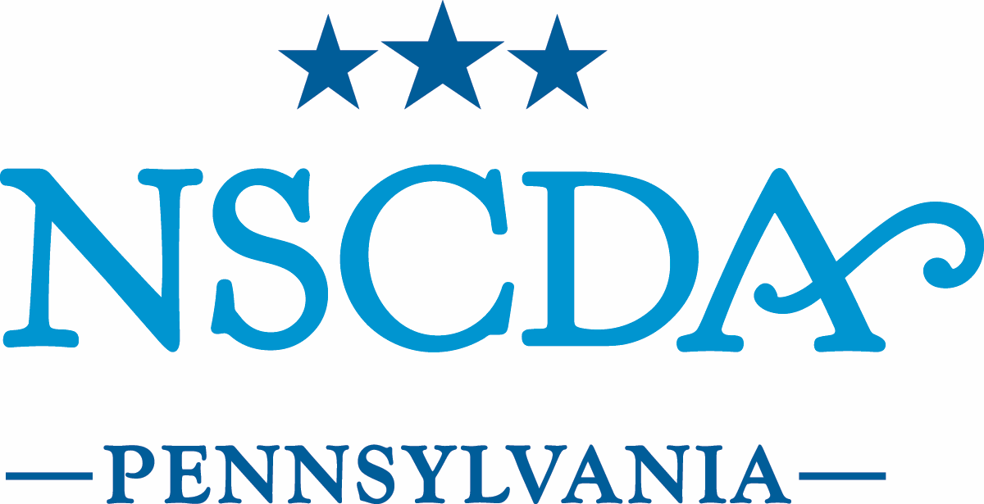

Board of Managers Meeting

September 9, 2016

MINUTES

- Call to Order: The Board of Managers of The National Society of The Colonial Dames of America in the Commonwealth of Pennsylvania met on September 9, 2016, at Headquarters. Anne Burnett, President, presiding, called the meeting to order.
Board members: present; excused
Officers
President Anne Burnett
Vice President Barbara Rogers
Governance & Nominating Virginia Whelan
Recording Secretary Catharine Klaus
Treasurer Margaret Conver
Registrar Constance Taylor
Associate States Registrar Sharon Holt
Stenton Chair Carol Rush
Patriotic Service Chair Elizabeth Mills
Historic Activities Chair Katherine Bieniosek

Managers
ACC Committee Chair Genevieve Ebbert
LDY Committee Chair Margaret Broussard
Program Chair DeeDee Heyward
Development Chair Alice Lea Tasman
Headquarters Chair Jane Foster Willson
Membership Chair Rebecca O’Neill
Assistant Treasurer Barbara Wood
Member-at-Large Elizabeth Marshall
Member-at-Large Gayla McCluskey

Honorary Members
Historian Elizabeth Laurent
Lady of Dumbarton Nina Schaefer
Assoc. Trustee, Friends of Sulgrave Manor Lisa Street
Regent of Gunston Hall Kristin Cahn von Seelen
Stenton Executive Director Dennis Pickeral
Headquarters Executive Assistant Adriana Robinson

NSCDA PA Past Presidents
Susan Armstrong
Barbara Cauffman
Sarah Congdon
Martha Lewis
Nancy Nimick (Honorary NSCDA PA President and Past National President)
Dora Rogers
Margaret Schiffer
Peggy Shaver
Alice Lea Tasman

BOM (to serve out terms)
Lee Manonian 2017
Eleanor Peterson 2017
Julia Ward 2017
Cornelia Schaefer 2018
Wendy Wells-Finn 2018

II. Minutes
A motion was made and seconded to approve the May and June 2016 minutes. The motion was approved.

III. Other Action Items
A. Treasurer’s Report – (See report by Peggy Conver).

B. Membership Committee
The following candidates were presented for membership:
1. Gloria Gal Gellman (Gloria Gal Seeburger) - proposed by Beckie O’Neill and seconded by Penny R. Perry. A motion to accept candidate was made by Peggy Conver, seconded by Alice Lea Tasman. The motion was approved.
2. Salome S. Prickett ( Salome Skold) - proposed by Mary Skold and seconded by Rebecca B. Baker. A motion to accept candidate was made by Barbara Rogers, seconded by Peggy Conver. The motion was approved.
3. Elizabeth Withey-Vandiver (Elizabeth Withey) - proposed by Catharine B. Brown, seconded by Kristin Cahn von Seelen. A motion to accept candidate was made by Carol Rush, seconded by Barbara Wood. The motion was approved.

C. Lineage Committee Scanning project – Registrar and Lineage Committee Chair Connie Taylor elaborated on her written report, explaining the rationale and need for Cloud-based storage (Dropbox, for example) for our scanned lineage papers, accessible to the Registrar, Adriana and possibly President or Membership Chair. Alice Lea recommended that Connie make the selection of cloud-storage based on her research and experience.

D. Executive Committee: The Executive Committee held an emergency (time-sensitive) meeting recently regarding offering a salary increase in the hope of retaining Kaelyn Taylor as Stenton Administrator & Program Director after she’d received a job offer in the for-profit sector. The E.C. approved an increase to offer, which she later accepted. A motion to ratify the E.C.’s action was made by Kristin Cahn von Seelen and seconded by Gina Whelan. The motion to ratify passed.

IV. Committee Updates

A, Development, Gala Committees: - Fundraising: Alice Lea Tasman reported on advanced sponsorships through preliminary gifts of $125,000 received to date and is committed to reaching $100k net. Ellie Penniman expressed thanks for all who contributed to the efforts. Help is still needed for the night of the gala and she has a sign-up sheet for those to volunteer. Peggy Shaver requests help the night of event to organize volunteers to usher guests through garden, etc. Alice Lea is gifting and procuring rosettes for all coming to dinner. Dennis thanked Ellie, our committee chair, as well as our honoree Alice Lea.

B. Strategic Planning Committee: – Barbara Rogers reported on the strategic planning moving forward and hiring Andy Mozenter from Concentrics Inc. as consultant. i.e., who are we, why would ladies join, and what do we do? A survey will be written and sent to all PA Dames followed by focus groups and a conference on strategic visioning and planning.

C. Governance Committee: – Gina Whelan supplied a handout noting that considering the By-laws, it might be helpful to have a 2nd VP but suggests not adding another person to the board; rather, selecting someone already on the board to have another title as VP.

D. Museum Properties
1. Stenton Committee: Dennis reported briefly that the committee’s historic structures subcommittee would be meeting soon to discuss using funds from the Stenton Restoration Fund to complete the Stenton Wing Restoration project, which is being funded in part by a PHMC matching grant.
2. Dumbarton House: Anne reported that Nina Schaefer will serve as our new Lady of Dumbarton House, for a two year term, 2016-18.
3. Gunston Hall: A reminder that the symposium on dissent, a 240th Anniversary of the VA Declaration of Rights-related event, will take place on October 5th at the Constitution Center. All are encouraged to attend.
4.Head quarters Committee: Jane Foster Willson reported that the committee will, with House Restoration Fund support, be moving forward to address urgent Assembly Room air conditioning and window repair needs. Final work is progressing to prepare 1618 Latimer for a return to income-producing use and described plans that would outsource the rental management.

E. Historical Activities – no update
F. Patriotic Service – no update
G. Registrar: – Connie Taylor announced new members Donna Bremer (PA-6877), Ashley Isaacs Ganz (PA-6878), Elizabeth Clatenberg (PA-6879), Linda Donovan Hawley (PA-6881) transfer from Washington, DC, Emily Ruderfer (PA-6882), and Christina Valimaki (PA-6886).
H. Associate States Registrar: – See Report.

V. Discussion Items

Update on meeting dates 2016-17 – April Stated Meeting will be a week later due to a conflict with Museum of American Revolution event.

VI. Announcements
Next Board Meeting: November 11th (Veteran’s Day) at 9:30 am at HQ
A reminder of our October 29th Bed Symposium at Stenton
Peggy Conver suggested the Drexel U. Furness building as a possible venue to utilize somehow.

A motion to adjourn the meeting was made by Barbara Rogers and seconded by Carol Rush. Motion passed.

